# Task 5: Improving the Quality / Testing FreeCol (Test Cases)

PLEASE NOT:

Due to memory/heap issues we have experienced as a group that seemed to be based on lines of code exceeding 600 lines or more, we were forced to select to develop test cases for those files that contained less than 600 lines of code. Even after extending the memory values within the eclipse.ini file we were still unable to work with those files that exceeded 600 lines of code.

*We selected those files where coverage was 0.0% to show code coverage improvement when developing our test cases. Some GUI files were selected but we felt that those classes contained within the “common” files were a bit more significant since they seemed to be used the most for our test case development.*

Test cases created to improve branch code coverage for the following:

1. Net.sf.freecol.client.gui/ChoiceItem.java: Achieved 88.9% branch coverage.
2. Net.sf.freecol.client.gui/FontLibrary.java: Achieved 69.6.% branch coverage.
3. net.sf.freecol.client.gui/FrameMotionListener.java: Achieved 96.1% branch coverage.
4. net.sf.freecol.client.gui/TerrainCursor.java: Achieved 94.7% branch coverage.

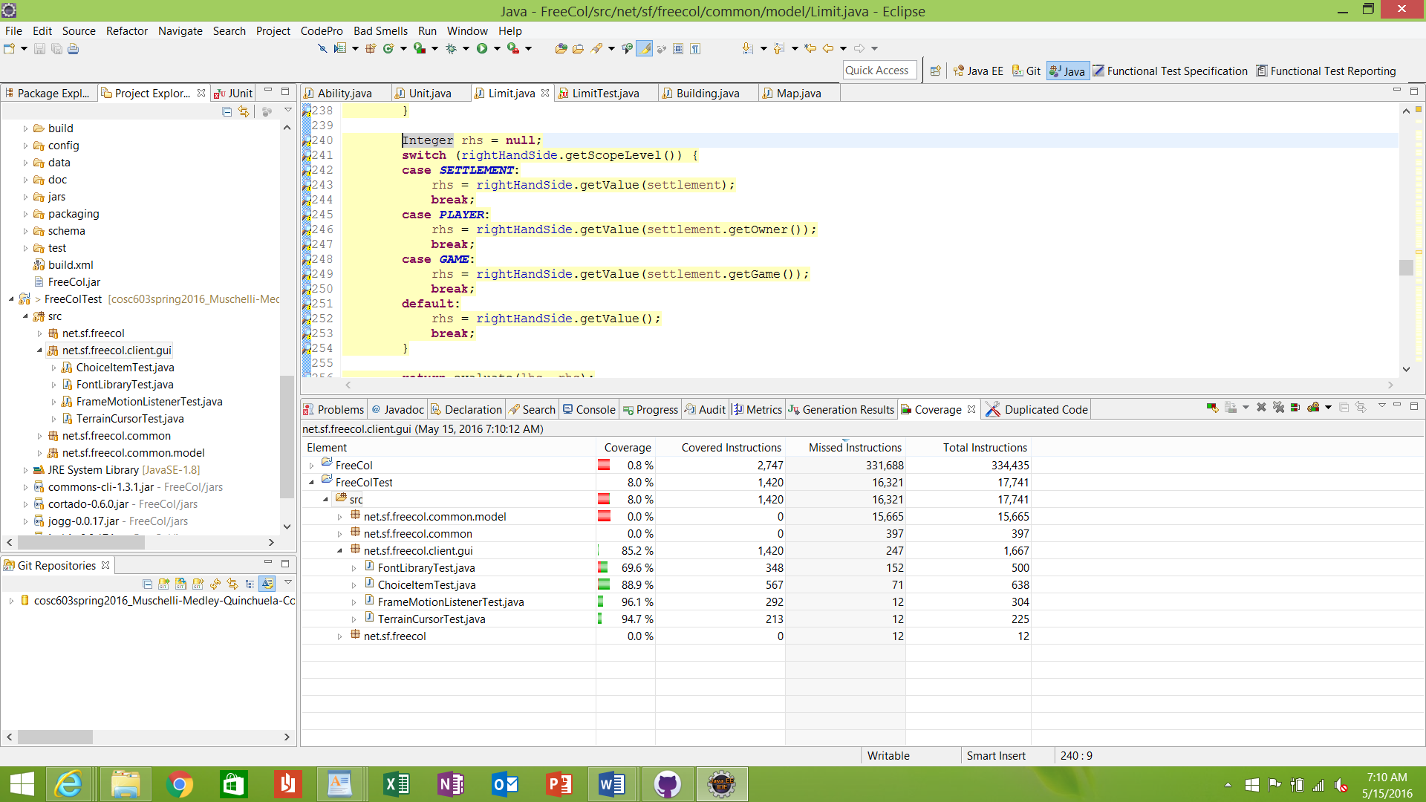

1. net.sf.freecol.common/FreeColSeed.java: Achieved 63.0% branch coverage.
2. Net.sf.freecol.common/ServerInfo.java: Achieved 96.4% branch coverage.

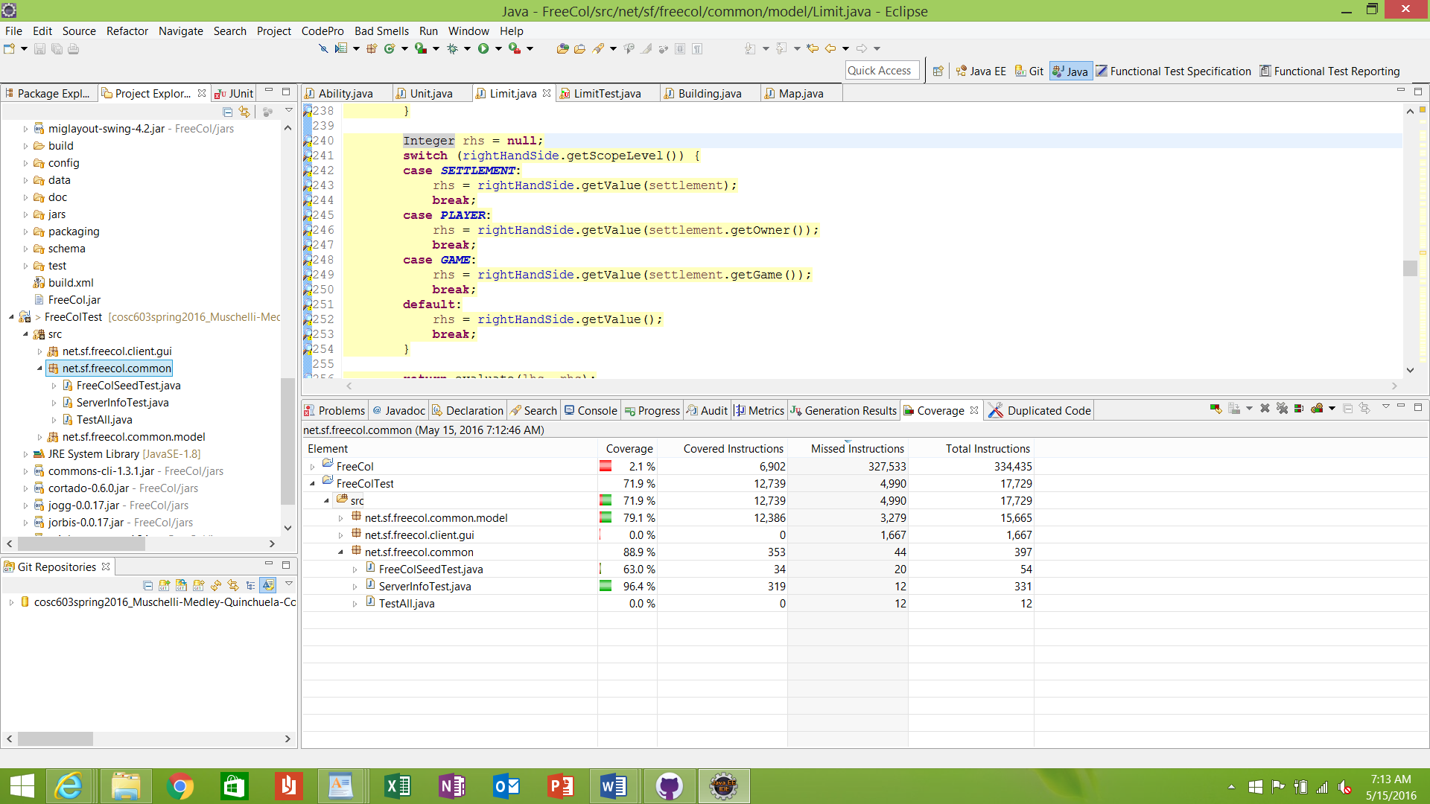

1. Net.sf.freecol.common.model/NationSummary.java: Achieved 49.1% code coverage.
2. Net.sf.freecol.common.model/Operand.java: Achieved 79.2% code coverage.
3. Net.sf.freecol.common.model/Limit.java: Achieved 85.1% code coverage.
4. Net.sf.freecol.common.model/IndianNationType.java: Achieved 85.9% code covereage.
5. Net.sf.freecol.common.model/Disaster.java: Achieved 87.7% code coverage.
6. Net.sf.freecol.common.model/NationOptions.java: Achieved 90.9% code coverage.
7. Net.sf.freecol.common.model/Nation.java: Achieved 93.3% code coverage.
8. Net.sf.freecol.common.model/NationType.java: Achieved 87.0% code coverage.
9. Net.sf.freecol.common.model/BuidableType.java: Achieved 92.9% code coverage.
10. Net.sf.freecol.common.model/AbstractUnit.java: Achieved 94.5% code coverage.
11. Net.sf.freecol.common.model/ResourceType.java: Achieved 87.47% code coverage.
12. Net.sf.freecol.common.model/AbstractGoods.java: Achieved 94.5% code coverage.
13. Net.sf.freecol.common.model/Stance.java: Achieved 98.2% code coverage.
14. Net.sf.freecol.common.model/Tension.java: Achieved 93.5% code coverage.
15. 